МИНОБРНАУКИ РОССИИ

Федеральное государственное бюджетное

образовательное учреждение высшего образования

«ЧЕРЕПОВЕЦКИЙ ГОСУДАРСТВЕННЫЙ УНИВЕРСИТЕТ»

Институт Информационных Технологий

Кафедра МПО ЭВМ

Дисциплина «Теория автоматов и формальных языков»

Лабораторная работа №7-8

«Построение дескрипторного кода. Построение регулярной грамматики»

Выполнил:

студент группы 1ПИб-02-3оп-22

Маркелов Сергей Александрович

Проверил:

доцент, к.т.н.

Ганичева Оксана Георгиевна

Череповец, 2024 год

Задания

**1 часть:** Написать часть/функцию лексического анализатора, обрабатывающую входную строку по конечному автомату на основе оператора выбора, формирование таблиц с классами лексем (это часть с предыдущей работы), реализующую построение дескрипторного кода и псевдокода.

Результат работы программы:

* Считываемая входная строка (код)
* Таблицы с выделенными классами лексем (в которых содержится информация для формирования дескрипторного и псевдокодов).
* Продемонстрировать в результатах работы, что дескрипторный и псевдокоды формируются правильно на скринах (повторные символы, изменение класса лексемы, набор символов типа "++++++" и т.д. )

**2 часть:** Построить регулярную грамматику, задающую тот же язык, что и конечный автомат (из лабораторной работы №2 1 семестра). Описание грамматики должно содержать совмещенную таблицу соответствия команды КА и правила РГ.

|  |  |
| --- | --- |
| Вариант | Задание |
| 14 | Оператор switch и if языка С++ |

1. Тестирование

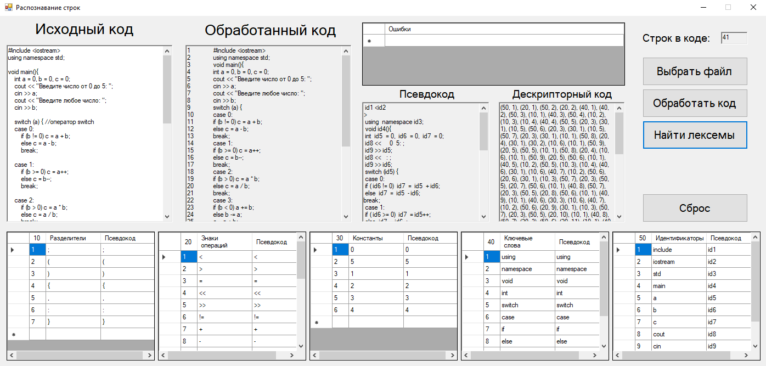

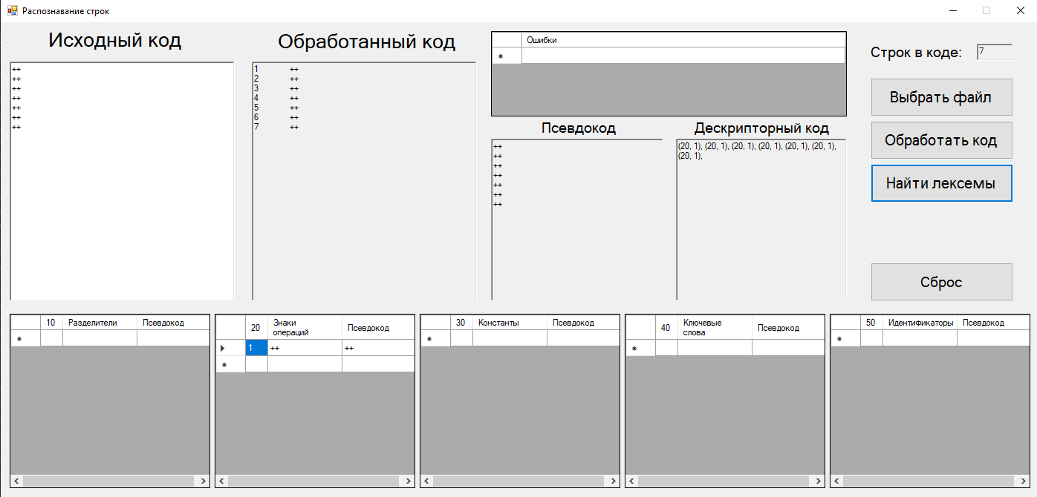

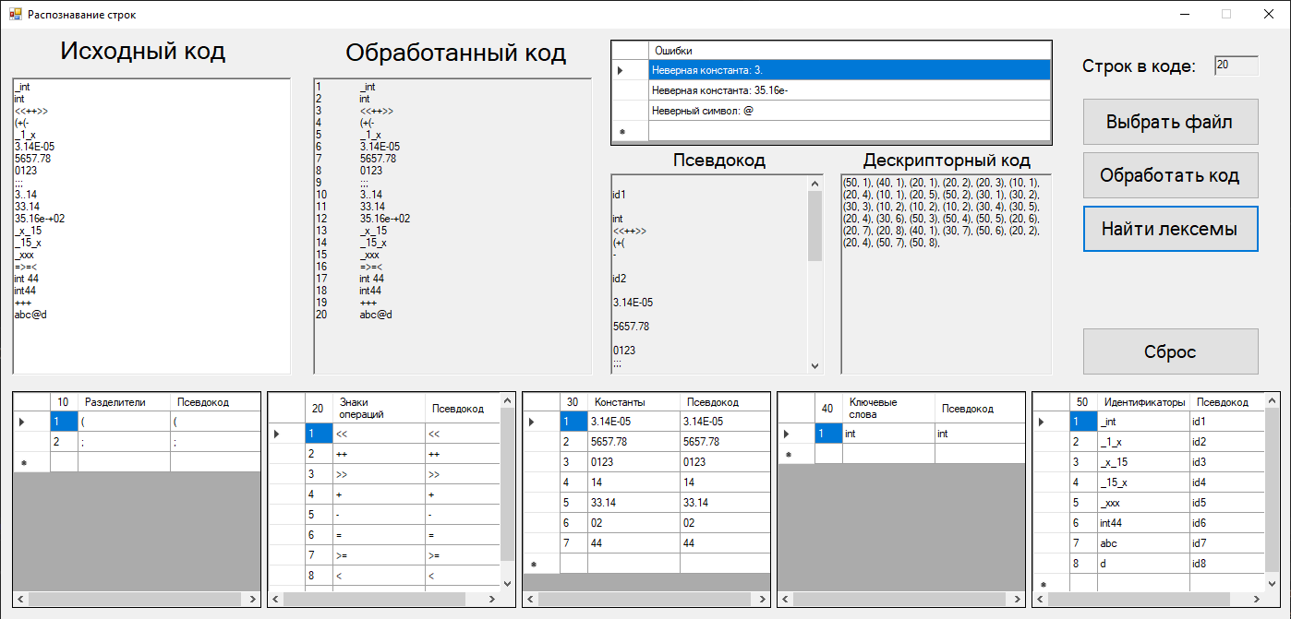

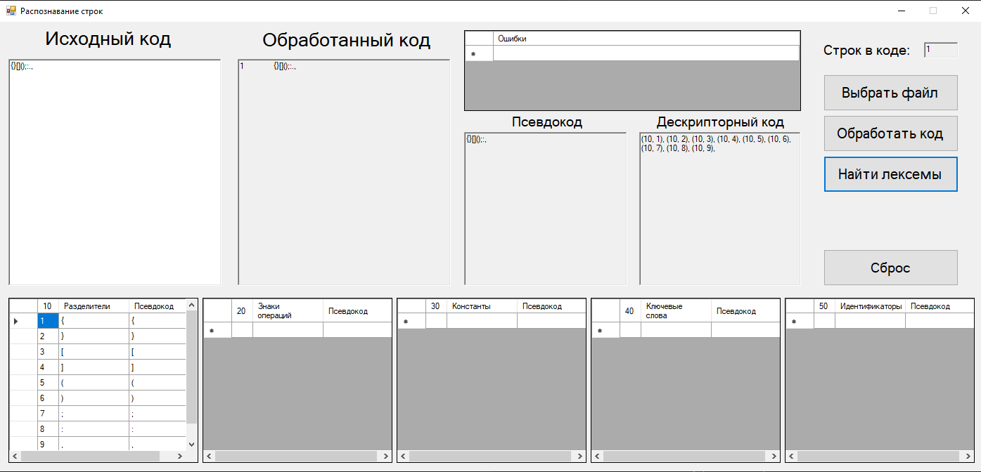

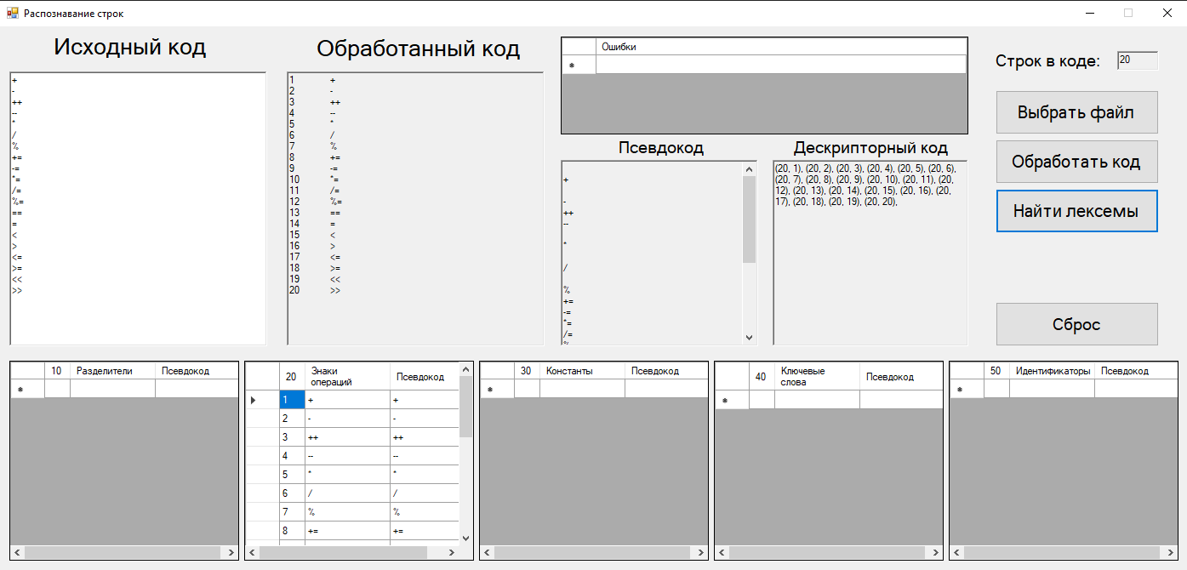

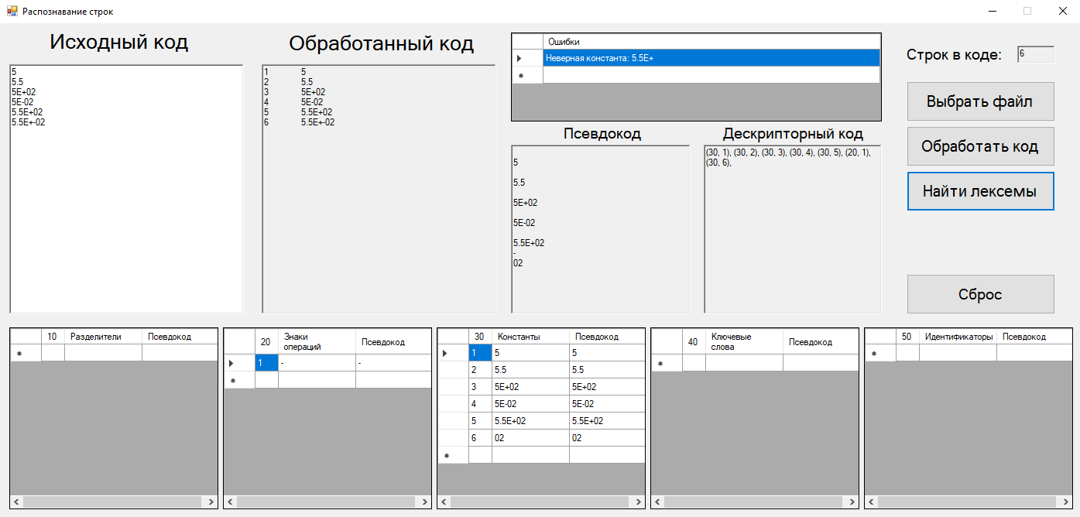

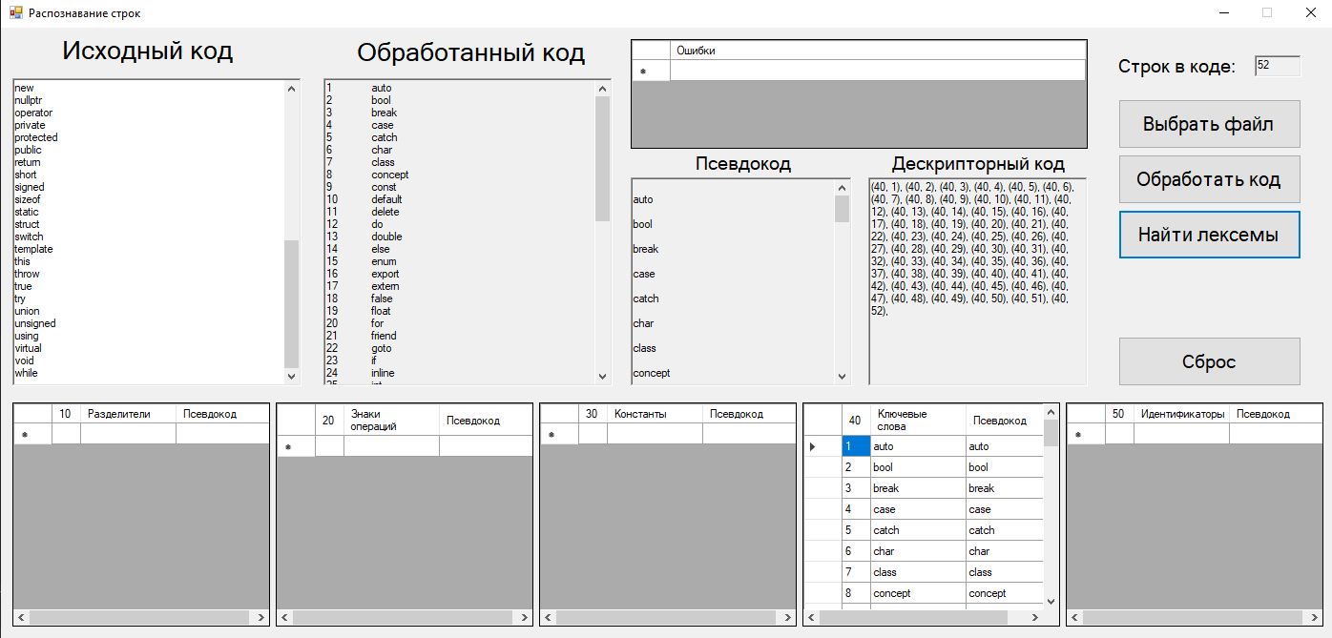

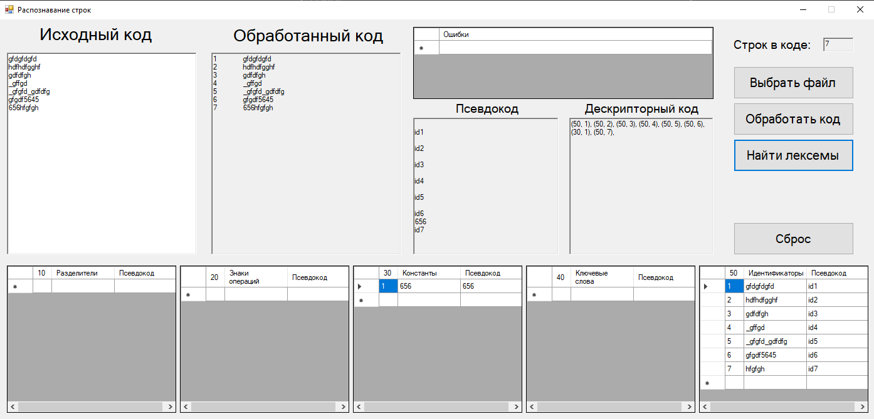

2. Программный код

private: System::Void button3_Click(System::Object^ sender, System::EventArgs^ e) {

String^ str0 = prog;

String^ symbol;

String^ count;

String^ pk;

string str00 = marshal_as<string>(str0), str = "";

bool f = false;

char c;

int s = 0;

for (int i = 0; i < str00.length(); i++) {

c = str00[i];

Automat2(c, s, str, i, f);

if (c == ' ' || c == '\n') richTextBox4->Text += Char::ToString(c);

if (s == 0) { //ошибки

if (f) {

symbol = "Неверный символ: ";

symbol += marshal_as<String^>(str);

cli::array<String^>^ row = gcnew cli::array<String^> { symbol };

dataGridView6->Rows->Add(row);

symbol = "";

str = "";

f = false;

}

}

if (s == 1) { //разделители

if (f) {

symbol += marshal_as<String^>(str);

if (!search(dataGridView1, symbol)) {

count_r++;

count = Convert::ToString(count_r);

pk = symbol;

cli::array<String^>^ row = gcnew cli::array<String^> { count, symbol, pk };

dataGridView1->Rows->Add(row);

richTextBox4->Text += pk;

richTextBox5->Text += "(10, " + count + "), ";

}

else {

richTextBox4->Text += psevdo;

richTextBox5->Text += "(10, " + id + "), ";

}

symbol = "";

str = "";

f = false;

s = 0;

count = "";

}

}

if (s >= 2 && s <= 9) { //знаки

if (f) {

for (int i = 0; i < str.length(); i++)

symbol += Char::ToString(str[i]);

if (!search(dataGridView2, symbol)) {

count_z++;

count = Convert::ToString(count_z);

pk = symbol;

cli::array<String^>^ row = gcnew cli::array<String^> { count, symbol, pk };

dataGridView2->Rows->Add(row);

richTextBox4->Text += pk;

richTextBox5->Text += "(20, " + count + "), ";

}

else {

richTextBox4->Text += psevdo;

richTextBox5->Text += "(20, " + id + "), ";

}

symbol = "";

str = "";

f = false;

s = 0;

count = "";

}

}

if (s >= 10 && s <= 13) { //константы

if (f) {

for (int i = 0; i < str.length(); i++)

symbol += Char::ToString(str[i]);

if (symbol[symbol->Length - 1] == '.' || symbol[symbol->Length - 1] == 'E' || symbol[symbol->Length - 1] == 'e' || symbol[symbol->Length - 1] == '+' || symbol[symbol->Length - 1] == '-') {

symbol = "Неверная константа: " + symbol;

cli::array<String^>^ row = gcnew cli::array<String^> { symbol };

dataGridView6->Rows->Add(row);

}

else if (!search(dataGridView3, symbol)) {

count_const++;

count = Convert::ToString(count_const);

pk = symbol;

cli::array<String^>^ row = gcnew cli::array<String^> { count, symbol, pk };

dataGridView3->Rows->Add(row);

richTextBox4->Text += pk;

richTextBox5->Text += "(30, " + count + "), ";

}

else {

richTextBox4->Text += psevdo;

richTextBox5->Text += "(30, " + id + "), ";

}

symbol = "";

str = "";

f = false;

s = 0;

count = "";

}

}

if (s == 17) { //ключевые слова

if (f) {

for (int i = 0; i < str.length(); i++)

symbol += Char::ToString(str[i]);

if (!search(dataGridView4, symbol)) {

count_key++;

count = Convert::ToString(count_key);

pk = symbol;

cli::array<String^>^ row = gcnew cli::array<String^> { count, symbol, pk };

dataGridView4->Rows->Add(row);

richTextBox4->Text += pk;

richTextBox5->Text += "(40, " + count + "), ";

}

else {

richTextBox4->Text += psevdo;

richTextBox5->Text += "(40, " + id + "), ";

}

symbol = "";

str = "";

f = false;

s = 0;

count = "";

pk = "";

}

}

if (s == 999) { //идентификаторы

if (f) {

for (int i = 0; i < str.length(); i++)

symbol += Char::ToString(str[i]);

if (!search(dataGridView5, symbol)) {

count_id++;

count = Convert::ToString(count_id);

pk = "id" + count;

cli::array<String^>^ row = gcnew cli::array<String^> { count, symbol, pk };

dataGridView5->Rows->Add(row);

richTextBox4->Text += pk;

richTextBox5->Text += "(50, " + count + "), ";

}

else {

richTextBox4->Text += psevdo;

richTextBox5->Text += "(50, " + id + "), ";

}

symbol = "";

str = "";

f = false;

s = 0;

count = "";

}

}

}

if (richTextBox5->Text != "") richTextBox5->Text = richTextBox5->Text->Substring(0, richTextBox5->Text->Length - 1);

string pcode = marshal_as<string>(richTextBox4->Text);

s = 0;

for (int i = 0; i < pcode.length(); i++) {

Automat1(pcode[i], s);

}

richTextBox4->Text = marshal_as<String^>(pcode);

3. Регулярная грамматика

A = {X, S, S0, F, δ}

X = {A…Z, a…z, 0…9, (, ), {, }, [, ], ‘, “, ;, ,, ., +, –, *, /, %, =, <, >, &, |, #}

S = {S0, S1, S2, … S193, S194, S999}

S0 = {S0}

F = {S1, S2, …, S12, S13, S17, S999}

S1 – разделители

S2 – S9 – знаки операций

S10 – S13 – константы

S17 – ключевые слова

S999 – идентификаторы

∂:

|  |  |  |  |
| --- | --- | --- | --- |
| (S0, ‘ ’) → S0 | (S0, \n) → S0 | (S0, {) → S1 | (S0, }) → S1 |
| (S0, ( ) → S1 | (S0, ) ) → S1 | (S0, [) → S1 | (S0, ]) → S1 |
| (S0, ;) → S1 | (S0, ,) → S1 | (S0, :) → S1 | (S0, +) → S2 |
| (S0, –) → S3 | (S0, <) → S4 | (S0, >) → S5 | (S0, =) → S6 |
| (S0, *) → S6 | (S0, /) → S6 | (S0, %) → S6 | (S0, !) → S6 |
| (S0, &) → S8 | (S0, |) → S9 | (S0, =) → S6 | (S0, 0…9) → S10 |
| (S0, a) → S14 | (S0, b) → S18 | (S0, c) → S24 | (S0, d) → S40 |
| (S0, e) → S53 | (S0, f) → S65 | (S0, g) → S77 | (S0, i) → S80 |
| (S0, l) → S85 | (S0, m) → S88 | (S0, n) → S94 | (S0, o) → S108 |
| (S0, p) → S115 | (S0, r) → S131 | (S0, s) → S136 | (S0, t) → S158 |
| (S0, u) → S171 | (S0, v) → S183 | (S0, w) → S191 | (S0, h) → S999 |
| (S0, j) → S999 | (S0, k) → S999 | (S0, q) → S999 | (S0, x) → S999 |
| (S0, y) → S999 | (S0, z) → S999 | (S0, _) → S999 | (S0, A…Z) → S999 |
| (S1) → S0 | (S2, +) → S7 | (S2, =) → S7 | (S3, –) → S7 |
| (S3, =) → S7 | (S4, <) → S7 | (S4, =) → S7 | (S5, >) → S7 |
| (S5, =) → S7 | (S6, =) → S7 | (S7) → S0 | (S8, &) → S7 |
| (S9, |) → S7 | (S10, 0…9) → S10 | (S10, .) → S11 | (S10, e) → S12 |
| (S10, E) → S12 | (S11, 0…9) → S11 | (S11, e) → S12 | (S11, E) → S12 |
| (S12, +) → S13 | (S12, –) → S13 | (S13, 0…9) → S13 | (S14, u) → S15 |
| (S15, t) → S16 | (S16, o) → S17 | (S17) → S0 | (S18, o) → S19 |
| (S18, r) → S21 | (S19, o) → S20 | (S20, l) → S17 | (S21, e) → S22 |
| (S22, a) → S23 | (S23, k) → S17 | (S24, a) → S25 | (S24, h) → S29 |
| (S24, l) → S31 | (S24, o) → S34 | (S25, s) → S26 | (S25, t) → S27 |
| (S26, e) → S17 | (S27, c) → S28 | (S28, h) → S17 | (S29, a) → S30 |
| (S30, a) → S17 | (S31, a) → S32 | (S32, s) → S33 | (S33, s) → S17 |
| (S34, n) → S35 | (S35, с) → S36 | (S35, s) → S39 | (S36, e) → S37 |
| (S37, p) → S38 | (S38, t) → S17 | (S39, t) → S17 | (S40, e) → S41 |
| (S40, o) → S49 | (S41, f) → S42 | (S41, l) → S46 | (S42, a) → S43 |
| (S43, u) → S44 | (S44, l) → S45 | (S45, t) → S17 | (S46, e) → S47 |
| (S47, t) → S48 | (S48, e) → S17 | (S49, u) → S50 | (S50, b) → S51 |
| (S51, l) → S52 | (S52, e) → S17 | (S53, l) → S54 | (S53, n) → S56 |
| (S53, x) → S58 | (S54, s) → S55 | (S55, e) → S17 | (S56, u) → S57 |
| (S57, m) → S17 | (S58, p) → S59 | (S58, t) → S62 | (S59, o) → S60 |
| (S60, r) → S61 | (S61, t) → S17 | (S62, e) → S63 | (S63, r) → S64 |
| (S64, n) → S17 | (S65, a) → S66 | (S65, l) → S69 | (S65, o) → S72 |
| (S65, r) → S73 | (S66, l) → S67 | (S67, s) → S68 | (S68, e) → S17 |
| (S69, o) → S70 | (S70, a) → S71 | (S71, t) → S71 | (S72, r) → S17 |
| (S73, i) → S74 | (S74, e) → S75 | (S75, n) → S76 | (S76, d) → S17 |
| (S77, o) → S78 | (S78, t) → S79 | (S79, o) → S17 | (S80, f) → S17 |
| (S80, n) → S81 | (S81, l) → S82 | (S82, t) → S17 | (S82, i) → S83 |
| (S83, n) → S84 | (S84, e) → S17 | (S85, o) → S86 | (S86, n) → S87 |
| (S87, g) → S17 | (S88, u) → S89 | (S89, t) → S90 | (S90, a) → S91 |
| (S91, b) → S92 | (S92, l) → S93 | (S93, e) → S17 | (S94, a) → S95 |
| (S94, e) → S102 | (S94, u) → S103 | (S95, m) → S96 | (S96, a) → S97 |
| (S97, s) → S98 | (S98, p) → S99 | (S99, a) → S100 | (S100, c) → S101 |
| (S101, e) → S17 | (S102, w) → S17 | (S103, l) → S104 | (S104, l) → S105 |
| (S105, p) → S106 | (S106, t) → S107 | (S107, r) → S17 | (S108, p) → S109 |
| (S109, e) → S110 | (S110, r) → S111 | (S111, a) → S112 | (S112, t) → S113 |
| (S113, o) → S114 | (S114, r) → S17 | (S115, r) → S116 | (S115, u) → S127 |
| (S116, i) → S117 | (S117, v) → S118 | (S118, a) → S119 | (S119, t) → S120 |
| (S120, e) → S17 | (S121, t) → S122 | (S122, e) → S123 | (S123, c) → S124 |
| (S124, t) → S125 | (S125, e) → S126 | (S126, d) → S127 | (S127, b) → S128 |
| (S128, l) → S129 | (S129, i) → S130 | (S130, c) → S17 | (S131, e) → S132 |
| (S132, t) → S133 | (S133, u) → S134 | (S134, r) → S135 | (S135, n) → S17 |
| (S136, h) → S137 | (S136, i) → S140 | (S136, t) → S147 | (S136, w) → S154 |
| (S137, o) → S138 | (S138, r) → S139 | (S139, i) → S17 | (S140, g) → S141 |
| (S140, z) → S144 | (S141, n) → S142 | (S142, e) → S143 | (S143, d) → S17 |
| (S144, e) → S145 | (S145, o) → S146 | (S146, f) → S17 | (S147, a) → S148 |
| (S147, r) → S151 | (S148, t) → S149 | (S149, i) → S150 | (S150, c) → S17 |
| (S151, u) → S152 | (S152, с) → S153 | (S153, t) → S17 | (S154, i) → S155 |
| (S155, t) → S156 | (S156, c) → S157 | (S157, h) → S17 | (S158, e) → S159 |
| (S158, h) → S165 | (S158, r) → S169 | (S159, m) → S160 | (S160, p) → S161 |
| (S161, l) → S162 | (S162, a) → S163 | (S163, t) → S164 | (S164, e) → S17 |
| (S165, i) → S166 | (S165, r) → S167 | (S166, s) → S17 | (S167, o) → S168 |
| (S168, w) → S17 | (S169, u) → S170 | (S169, y) → S17 | (S170, e) → S17 |
| (S171, n) → S172 | (S171, s) → S180 | (S172, i) → S173 | (S172, s) → S175 |
| (S173, o) → S174 | (S174, n) → S17 | (S175, i) → S176 | (S176, g) → S177 |
| (S177, n) → S178 | (S178, e) → S179 | (S179, d) → S17 | (S180, i) → S181 |
| (S181, n) → S182 | (S182, g) → S17 | (S183, i) → S184 | (S183, o) → S189 |
| (S184, r) → S185 | (S185, t) → S186 | (S186, u) → S187 | (S187, a) → S188 |
| (S188, l) → S17 | (S189, i) → S190 | (S190, d) → S17 | (S191, h) → S192 |
| (S192, i) → S193 | (S193, l) → S194 | (S194, e) → S17 |  |

|  |  |
| --- | --- |
| Формальное описание конечного автомата | Формальное описание регулярной грамматики по заданному конечному автомату |
| X = {A…Z, a…z, 0…9, (, ), {, }, [, ], ‘, “, ;, ,, ., +, –, *, /, %, =, <, >, &, |, #}  S = {S0, S1, S2, … S193, S194, S999}  S0 = {S0}  F = {S1, S2, …, S12, S13, S17, S999}  S1 – разделители  S2 – S9 – знаки операций  S10 – S13 – константы  S17 – ключевые слова  S999 – идентификаторы  ∂: |  |
| (S0, ‘ ’) → S0 | S0 → ‘ ’ S0  S0 → ‘ ’ |
| (S0, \n) → S0 | S0 → \n S0  S0 → \n |
| (S0, {) → S1 | S0 → { S1  S0 → { |
| (S0, }) → S1 | S0 → } S1  S0 → } |
| (S0, ( ) → S1 | S0 → ( S1  S0 → ( |
| (S0, ) ) → S1 | S0 → ) S1  S0 → ) |
| (S0, [) → S1 | S0 → [ S1  S0 → [ |
| (S0, ]) → S1 | S0 → ] S1  S0 → ] |
| (S0, ;) → S1 | S0 → ; S1  S0 → ; |
| (S0, ,) → S1 | S0 → , S1  S0 → , |
| (S0, :) → S1 | S0 → : S1  S0 → : |
| (S0, +) → S2 | S0 → + S2  S0 → + |
| (S0, –) → S3 | S0 → – S3  S0 → – |
| (S0, <) → S4 | S0 → < S4  S0 → < |
| (S0, >) → S5 | S0 → > S5  S0 → > |
| (S0, =) → S6 | S0 → = S6  S0 → = |
| (S0, *) → S6 | S0 → * S6  S0 → * |
| (S0, /) → S6 | S0 → / S6  S0 → / |
| (S0, %) → S6 | S0 → % S6  S0 → % |
| (S0, !) → S6 | S0 → ! S6  S0 → ! |
| (S0, &) → S8 | S0 → & S8  S0 → & |
| (S0, |) → S9 | S0 → | S9  S0 → | |
| (S0, 0…9) → S10 | S0 → 0…9 S10  S0 → 0…9 |
| (S0, a) → S14 | S0 → a S14 |
| (S0, b) → S18 | S0 → b S18 |
| (S0, c) → S24 | S0 → c S24 |
| (S0, d) → S40 | S0 → d S40 |
| (S0, e) → S53 | S0 → e S53 |
| (S0, f) → S65 | S0 → f S65 |
| (S0, g) → S77 | S0 → g S77 |
| (S0, i) → S80 | S0 → i S80 |
| (S0, l) → S85 | S0 → l S85 |
| (S0, m) → S88 | S0 → m S88 |
| (S0, n) → S94 | S0 → n S94 |
| (S0, o) → S108 | S0 → o S108 |
| (S0, p) → S115 | S0 → p S115 |
| (S0, r) → S131 | S0 → r S131 |
| (S0, s) → S136 | S0 → s S136 |
| (S0, t) → S158 | S0 → t S158 |
| (S0, u) → S171 | S0 → u S171 |
| (S0, v) → S183 | S0 → v S183 |
| (S0, w) → S191 | S0 → w S191 |
| (S0, h) → S999 | S0 → h S999  S0 → h |
| (S0, j) → S999 | S0 → j S999  S0 → j |
| (S0, k) → S999 | S0 → k S999  S0 → k |
| (S0, q) → S999 | S0 → q S999  S0 → q |
| (S0, x) → S999 | S0 → x S999  S0 → x |
| (S0, y) → S999 | S0 → y S999  S0 → y |
| (S0, z) → S999 | S0 → z S999  S0 → z |
| (S0, _) → S999 | S0 → _ S999  S0 → _ |
| (S0, A…Z) → S999 | S0 → A…Z S999  S0 → A…Z |
| (S1) → S0 | S1 → S0 |
| (S2, +) → S7 | S2 → + S7  S2 → + |
| (S2, =) → S7 | S2 → = S7  S2 → = |
| (S3, –) → S7 | S3 → – S7  S3 → – |
| (S3, =) → S7 | S3 → = S7  S3 → = |
| (S4, <) → S7 | S4 → < S7  S4 → < |
| (S4, =) → S7 | S4 → = S7  S4 → = |
| (S5, >) → S7 | S5 → > S7  S5 → > |
| (S5, =) → S7 | S5 → = S7  S5 → = |
| (S6, =) → S7 | S6 → = S7  S6 → = |
| (S7) → S0 | S7 → S0 |
| (S8, &) → S7 | S8 → & S7  S8 → & |
| (S9, |) → S7 | S9 → | S7  S9 → | |
| (S10, 0…9) → S10 | S10 → 0…9 S7  S10 → 0…9 |
| (S10, .) → S11 | S10 → . S7  S10 → . |
| (S10, e) → S12 | S10 → e S12  S10 → e |
| (S10, E) → S12 | S10 → E S12  S10 → E |
| (S11, 0…9) → S11 | S11 → 0…9 S11  S11 → 0…9 |
| (S11, e) → S12 | S11 → e S12  S11 → e |
| (S11, E) → S12 | S11 → E S12  S11 → E |
| (S12, +) → S13 | S12 → + S13  S12 → + |
| (S12, –) → S13 | S12 → – S13  S12 → – |
| (S13, 0…9) → S13 | S13 → 0…9 S13  S13 → 0…9 |
| (S14, u) → S15 | S14 → u S15 |
| (S15, t) → S16 | S15 → t S16 |
| (S16, o) → S17 | S16 → o S17  S16 → o |
| (S17) → S0 | S17 → S0 |
| (S18, o) → S19 | S18 → o S19 |
| (S18, r) → S21 | S19 → r S17 |
| (S19, o) → S20 | S19 → o S20 |
| (S20, l) → S17 | S20 → l S17  S20 → l |
| (S21, e) → S22 | S21 → e S22 |
| (S22, a) → S23 | S22 → a S23 |
| (S23, k) → S17 | S23 → k S17  S23 → k |
| (S24, a) → S25 | S24 → a S25 |
| (S24, h) → S29 | S24 → h S29 |
| (S24, l) → S31 | S24 → l S31 |
| (S24, o) → S34 | S24 → o S34 |
| (S25, s) → S26 | S25 → s S26 |
| (S25, t) → S27 | S25 → t S27 |
| (S26, e) → S17 | S26 → e S17  S26 → e |
| (S27, c) → S28 | S27 → c S28 |
| (S28, h) → S17 | S28 → h S17  S28 → h |
| (S29, a) → S30 | S29 → a S30 |
| (S30, a) → S17 | S30 → a S17  S30 → a |
| (S31, a) → S32 | S31 → a S32 |
| (S32, s) → S33 | S32 → s S33 |
| (S33, s) → S17 | S33 → s S17  S33 → s |
| (S34, n) → S35 | S34 → n S35 |
| (S35, с) → S36 | S35 → c S36 |
| (S35, s) → S39 | S35 → s S39 |
| (S36, e) → S37 | S36 → e S37 |
| (S37, p) → S38 | S37 → p S38 |
| (S38, t) → S17 | S38 → t S17  S38 → t |
| (S39, t) → S17 | S39 → t S17  S39 → t |
| (S40, e) → S41 | S40 → e S41 |
| (S40, o) → S49 | S40 → o S49 |
| (S41, f) → S42 | S41 → f S42 |
| (S41, l) → S46 | S41 → l S46 |
| (S42, a) → S43 | S42 → a S43 |
| (S43, u) → S44 | S43 → u S44 |
| (S44, l) → S45 | S44 → l S45 |
| (S45, t) → S17 | S45 → t S17  S45 → t |
| (S46, e) → S47 | S46 → e S47 |
| (S47, t) → S48 | S47 → t S48 |
| (S48, e) → S17 | S48 → t S17  S48 → t |
| (S49, u) → S50 | S49 → u S50 |
| (S50, b) → S51 | S50 → b S51 |
| (S51, l) → S52 | S51 → l S52 |
| (S52, e) → S17 | S52 → e S17  S52 → e |
| (S53, l) → S54 | S53 → l S54 |
| (S53, n) → S56 | S53 → n S56 |
| (S53, x) → S58 | S53 → x S58 |
| (S54, s) → S55 | S54 → s S55 |
| (S55, e) → S17 | S55 → e S17  S55 → e |
| (S56, u) → S57 | S56 → u S57 |
| (S57, m) → S17 | S57 → m S17  S57 → m |
| (S58, p) → S59 | S58 → p S59 |
| (S58, t) → S62 | S58 → t S62 |
| (S59, o) → S60 | S59 → o S60 |
| (S60, r) → S61 | S60 → r S61 |
| (S61, t) → S17 | S61 → t S17  S61 → t |
| (S62, e) → S63 | S62 → e S63 |
| (S63, r) → S64 | S63 → e S64 |
| (S64, n) → S17 | S64 → n S17  S64 → n |
| (S65, a) → S66 | S65 → a S66 |
| (S65, l) → S69 | S65 → l S69 |
| (S65, o) → S72 | S65 → o S72 |
| (S65, r) → S73 | S65 → r S73 |
| (S66, l) → S67 | S66 → l S67 |
| (S67, s) → S68 | S67 → s S68 |
| (S68, e) → S17 | S68 → e S17  S68 → e |
| (S69, o) → S70 | S69 → o S70 |
| (S70, a) → S71 | S70 → a S71 |
| (S71, t) → S17 | S71 → t S17  S71 → t |
| (S72, r) → S17 | S72 → r S17  S72 → r |
| (S73, i) → S74 | S73 → i S74 |
| (S74, e) → S75 | S74 → e S75 |
| (S75, n) → S76 | S75 → n S76 |
| (S76, d) → S17 | S76 → d S17  S76 → d |
| (S77, o) → S78 | S77 → o S78 |
| (S78, t) → S79 | S78 → t S79 |
| (S79, o) → S17 | S79 → o S17  S79 → o |
| (S80, f) → S17 | S80 → f S17  S80 → f |
| (S80, n) → S81 | S80 → n S81 |
| (S81, l) → S82 | S81 → l S82 |
| (S82, t) → S17 | S82 → t S17  S82 → t |
| (S82, i) → S83 | S82 → i S83 |
| (S83, n) → S84 | S83 → n S84 |
| (S84, e) → S17 | S84 → e S17  S84 → e |
| (S85, o) → S86 | S85 → e S86 |
| (S86, n) → S87 | S86 → n S87 |
| (S87, g) → S17 | S87 → g S17  S87 → g |
| (S88, u) → S89 | S88 → u S89 |
| (S89, t) → S90 | S89 → t S90 |
| (S90, a) → S91 | S90 → a S91 |
| (S91, b) → S92 | S91 → b S92 |
| (S92, l) → S93 | S92 → l S93 |
| (S93, e) → S17 | S93 → e S17  S93 → e |
| (S94, a) → S95 | S94 → a S95 |
| (S94, e) → S102 | S94 → e S102 |
| (S94, u) → S103 | S94 → u S103 |
| (S95, m) → S96 | S95 → m S96 |
| (S96, a) → S97 | S96 → a S97 |
| (S97, s) → S98 | S97 → s S98 |
| (S98, p) → S99 | S98 → p S99 |
| (S99, a) → S100 | S99 → a S100 |
| (S100, c) → S101 | S100 → c S101 |
| (S101, e) → S17 | S101 → e S17  S101 → e |
| (S102, w) → S17 | S102 → w S17  S102 → w |
| (S103, l) → S104 | S103 → l S104 |
| (S104, l) → S105 | S104 → l S105 |
| (S105, p) → S106 | S105 → p S106 |
| (S106, t) → S107 | S106 → t S107 |
| (S107, r) → S17 | S107 → r S17  S107 → r |
| (S108, p) → S109 | S108 → p S109  S108 → p |
| (S109, e) → S110 | S109 → e S110  S109 → e |
| (S110, r) → S111 | S110 → r S111  S110 → r |
| (S111, a) → S112 | S111 → a S112  S111 → a |
| (S112, t) → S113 | S112 → t S113 |
| (S113, o) → S114 | S113 → o S114 |
| (S114, r) → S17 | S114 → r S17  S114 → r |
| (S115, r) → S116 | S115 → r S116 |
| (S115, u) → S127 | S115 → u S127 |
| (S116, i) → S117 | S116 → i S117 |
| (S117, v) → S118 | S117 → v S117 |
| (S118, a) → S119 | S118 → a S119 |
| (S119, t) → S120 | S119 → t S120 |
| (S120, e) → S17 | S120 → e S17  S120 → e |
| (S121, t) → S122 | S121 → t S122 |
| (S122, e) → S123 | S122 → e S123 |
| (S123, c) → S124 | S123 → c S124 |
| (S124, t) → S125 | S124 → t S125 |
| (S125, e) → S126 | S125 → e S126 |
| (S126, d) → S127 | S126 → d S127 |
| (S127, b) → S128 | S127 → b S128 |
| (S128, l) → S129 | S128 → l S129 |
| (S129, i) → S130 | S129 → i S130 |
| (S130, c) → S17 | S130 → c S17  S17 → c |
| (S131, e) → S132 | S131 → e S132 |
| (S132, t) → S133 | S132 → t S133 |
| (S133, u) → S134 | S133 → u S134 |
| (S134, r) → S135 | S134 → r S135 |
| (S135, n) → S17 | S135 → n S17  S135 → n |
| (S136, h) → S137 | S136 → h S137 |
| (S136, i) → S140 | S136 → i S140 |
| (S136, t) → S147 | S136 → t S147 |
| (S136, w) → S154 | S136 → w S154 |
| (S137, o) → S138 | S137 → o S138 |
| (S138, r) → S139 | S138 → r S139 |
| (S139, i) → S17 | S139 → i S17  S139 → i |
| (S140, g) → S141 | S140 → g S141 |
| (S140, z) → S144 | S140 → z S144 |
| (S141, n) → S142 | S141 → n S142 |
| (S142, e) → S143 | S142 → e S143 |
| (S143, d) → S17 | S143 → d S17  S143 → d |
| (S144, e) → S145 | S144 → e S145 |
| (S145, o) → S146 | S145 → o S146 |
| (S146, f) → S17 | S146 → f S17  S146 → f |
| (S147, a) → S148 | S147 → a S148 |
| (S147, r) → S151 | S147 → r S151 |
| (S148, t) → S149 | S148 → t S149 |
| (S149, i) → S150 | S149 → i S150 |
| (S150, c) → S17 | S150 → c S17  S150 → c |
| (S151, u) → S152 | S151 → u S152 |
| (S152, с) → S153 | S152 → c S153 |
| (S153, t) → S17 | S153 → t S17  S153 → t |
| (S154, i) → S155 | S154 → i S155 |
| (S155, t) → S156 | S155 → t S156 |
| (S156, c) → S157 | S156 → c S157 |
| (S157, h) → S17 | S157 → h S17  S157 → h |
| (S158, e) → S159 | S158 → e S159 |
| (S158, h) → S165 | S158 → h S165 |
| (S158, r) → S169 | S158 → r S169 |
| (S159, m) → S160 | S159 → m S160 |
| (S160, p) → S161 | S160 → p S161 |
| (S161, l) → S162 | S161 → l S162 |
| (S162, a) → S163 | S162 → a S163 |
| (S163, t) → S164 | S163 → t S164 |
| (S164, e) → S17 | S164 → e S17  S164 → e |
| (S165, i) → S166 | S165 → i S166 |
| (S165, r) → S167 | S165 → r S167 |
| (S166, s) → S17 | S166 → s S17  S166 → s |
| (S167, o) → S168 | S167 → o S168 |
| (S168, w) → S17 | S168 → w S17  S168 → w |
| (S169, u) → S170 | S169 → u S170 |
| (S169, y) → S17 | S169 → y S17  S169 → y |
| (S170, e) → S17 | S170 → e S17  S170 → e |
| (S171, n) → S172 | S171 → n S172 |
| (S171, s) → S180 | S171 → s S180 |
| (S172, i) → S173 | S172 → i S173 |
| (S172, s) → S175 | S172 → s S175 |
| (S173, o) → S174 | S173 → o S174 |
| (S174, n) → S17 | S174 → n S17  S174 → n |
| (S175, i) → S176 | S175 → i S176 |
| (S176, g) → S177 | S176 → g S177 |
| (S177, n) → S178 | S177 → n S178 |
| (S178, e) → S179 | S178 → e S179 |
| (S179, d) → S17 | S179 → d S17  S179 → d |
| (S180, i) → S181 | S180 → i S181 |
| (S181, n) → S182 | S181 → n S182 |
| (S182, g) → S17 | S182 → g S17  S182 → g |
| (S183, i) → S184 | S183 → i S184 |
| (S183, o) → S189 | S183 → o S189 |
| (S184, r) → S185 | S184 → r S185 |
| (S185, t) → S186 | S185 → t S186 |
| (S186, u) → S187 | S186 → u S187 |
| (S187, a) → S188 | S187 → a S188 |
| (S188, l) → S17 | S188 → l S17  S188 → l |
| (S189, i) → S190 | S189 → i S190 |
| (S190, d) → S17 | S190 → d S17  S190 → d |
| (S191, h) → S192 | S191 → h S192 |
| (S192, i) → S193 | S192 → i S193 |
| (S193, l) → S194 | S193 → l S194 |
| (S194, e) → S17 | S194 → e S17 |

Вывод

В ходе выполнения лабораторной работы была написана часть лексического анализатора, реализующая построение дескрипторного кода и псевдокода.

Также была построена регулярная грамматика, задающая тот же язык, что и конечный автомат. Описание грамматики содержит совмещенную таблицу соответствия команды КА и правила РГ.